DAA LAB 1
Comparative Study of Algorithm Efficiency
and Performance Analysis
FILE 1 — EXPERIMENTAL ANALYSIS

Student Name | Tamanna
Roll No. | 2401201138
Course / Semester | BCA / 5th
Subject | Design and Analysis of Algorithms

1. Question
Perform experimental analysis using different input sizes and input conditions (sorted, reverse-sorted, and random data). Record execution time and memory usage.

2. Objective
The objective of this experiment is to experimentally compare the performance of different sorting algorithms by measuring their execution time and peak memory usage for different input sizes and input conditions.

3. Algorithms Used
- Bubble Sort
- Insertion Sort
- Merge Sort
- Quick Sort (last element used as pivot)

4. Experimental Setup
The experiment was implemented in Python and executed in VS Code/Jupyter Notebook. Execution time was measured using time.perf_counter(), while peak memory allocation was measured using tracemalloc. Random input data was generated and then converted into sorted and reverse-sorted forms for comparison.
Parameter | Experimental Setting
Input sizes | 100, 500, 1000, 2000
Input conditions | Sorted, Reverse Sorted, Random
Sorting algorithms | Bubble, Insertion, Merge, Quick
Time measurement | time.perf_counter()
Memory measurement | tracemalloc peak memory
Memory unit | KB (peak bytes / 1024)

5. Experimental Analysis Code
import time
import tracemalloc
import random
import csv
def bubble_sort(arr):
n = len(arr)
for i in range(n):
swapped = False
for j in range(0, n - i - 1):
if arr[j] > arr[j + 1]:
arr[j], arr[j + 1] = arr[j + 1], arr[j]
swapped = True
if not swapped:
break
def insertion_sort(arr):
for i in range(1, len(arr)):
key = arr[i]
j = i - 1
while j >= 0 and arr[j] > key:
arr[j + 1] = arr[j]
j -= 1
arr[j + 1] = key
def merge_sort(arr):
if len(arr) <= 1:
return
mid = len(arr) // 2
left = arr[:mid]
right = arr[mid:]
merge_sort(left)
merge_sort(right)
i = j = k = 0
while i < len(left) and j < len(right):
if left[i] <= right[j]:
arr[k] = left[i]
i += 1
else:
arr[k] = right[j]
j += 1
k += 1
while i < len(left):
arr[k] = left[i]
i += 1
k += 1
while j < len(right):
arr[k] = right[j]
j += 1
k += 1
def quick_sort(arr):
def partition(low, high):
pivot = arr[high]
i = low - 1
for j in range(low, high):
if arr[j] <= pivot:
i += 1
arr[i], arr[j] = arr[j], arr[i]
arr[i + 1], arr[high] = arr[high], arr[i + 1]
return i + 1
def solve(low, high):
if low < high:
pi = partition(low, high)
solve(low, pi - 1)
solve(pi + 1, high)
solve(0, len(arr) - 1)
def measure(sort_function, data):
arr = data.copy()
tracemalloc.start()
start = time.perf_counter()
sort_function(arr)
end = time.perf_counter()
current, peak = tracemalloc.get_traced_memory()
tracemalloc.stop()
return end - start, peak / 1024
algorithms = {
"Bubble Sort": bubble_sort,
"Insertion Sort": insertion_sort,
"Merge Sort": merge_sort,
"Quick Sort": quick_sort
}
input_sizes = [100, 500, 1000, 2000]
conditions = ["Sorted", "Reverse Sorted", "Random"]
results = []
print("=" * 90)
print("DAA LAB 1 - EXPERIMENTAL ANALYSIS")
print("Sorting Algorithms")
print("=" * 90)
for n in input_sizes:
random_data = [random.randint(1, 100000) for _ in range(n)]
sorted_data = sorted(random_data)
reverse_data = sorted_data[::-1]
data_sets = {
"Sorted": sorted_data,
"Reverse Sorted": reverse_data,
"Random": random_data
}
for condition in conditions:
data = data_sets[condition]
print("-" * 90)
print(f"Input Size: {n}")
print(f"Condition: {condition}")
print("-" * 90)
for name, algorithm in algorithms.items():
try:
time_taken, memory_used = measure(algorithm, data)
results.append([
n, condition, name,
time_taken, memory_used
])
print(
f"{name:<18}"
f" Time = {time_taken:.6f} sec"
f" Memory = {memory_used:.3f} KB"
)
except RecursionError:
print(f"{name:<18} Recursion Error")
with open("lab1_results.csv", "w", newline="") as file:
writer = csv.writer(file)
writer.writerow([
"Input Size",
"Condition",
"Algorithm",
"Execution Time (sec)",
"Memory Usage (KB)"
])
writer.writerows(results)
print()
print("=" * 90)
print("EXPERIMENT COMPLETED SUCCESSFULLY")
print("=" * 90)
print(f"Total experiments recorded: {len(results)}")
print()
print("Results saved in:")
print("lab1_results.csv")
print("=" * 90)

6. Output Screenshot
The following screenshot shows the successful completion of the experimental analysis and the generated results file.
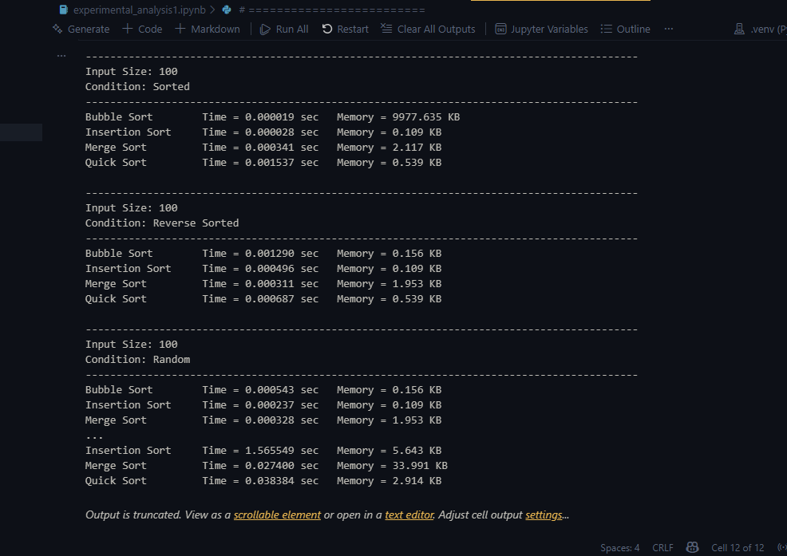
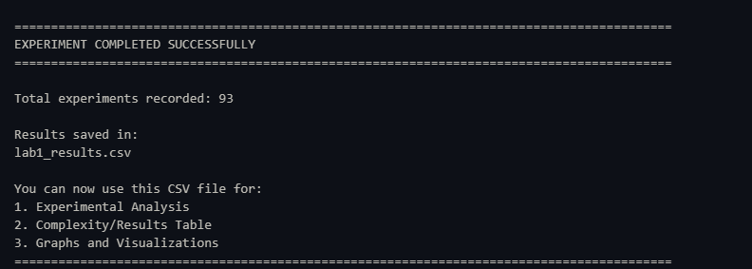
Figure 1. Experimental analysis completed successfully and results saved to lab1_results.csv.

7. Recorded Experimental Results
The execution-time and peak-memory measurements were recorded in lab1_results.csv. The CSV contains the measured values for the four sorting algorithms across sorted, reverse-sorted, and random input conditions.
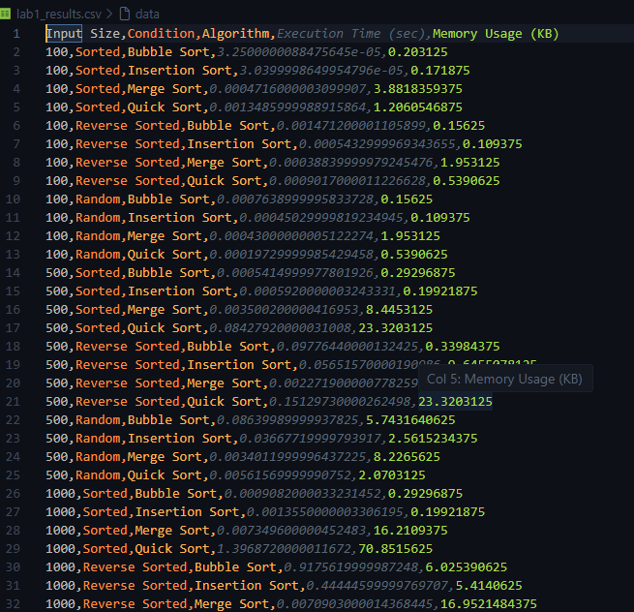
Figure 2. Recorded execution-time and memory measurements from lab1_results.csv.

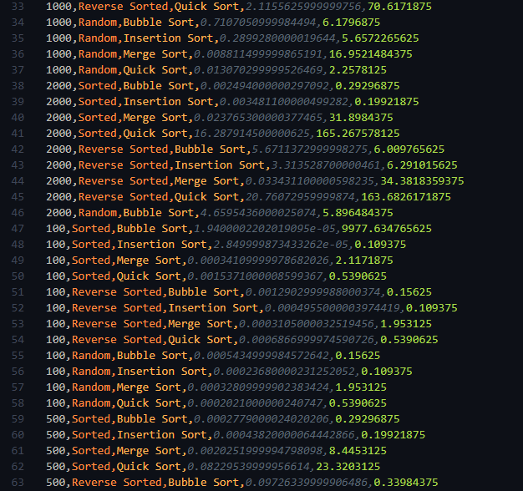
Figure 3. Recorded execution-time and memory measurements from lab1_results.csv.

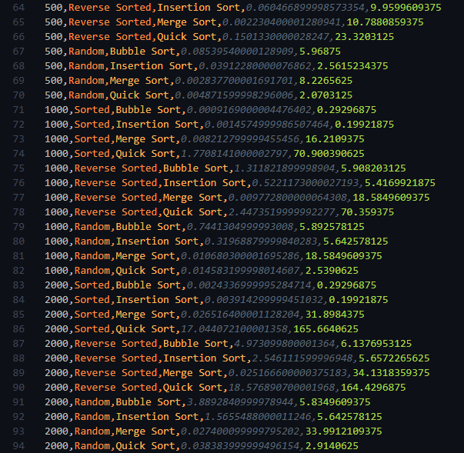
Figure 4. Recorded execution-time and memory measurements from lab1_results.csv.

8. Experimental Observations
- Bubble Sort and Insertion Sort generally require more time as the input size increases, particularly for reverse-sorted and random data.
- Merge Sort shows comparatively stable execution time as input size increases because its time complexity remains O(n log n) in the best, average, and worst cases.
- Quick Sort is highly dependent on input order when the last element is selected as the pivot. Ordered inputs can cause a large increase in execution time because of unbalanced partitions.
- For the measured runs, Quick Sort is comparatively fast on random data but becomes much slower on sorted and reverse-sorted inputs at larger sizes.
- The memory measurements are peak allocations reported by tracemalloc and therefore include measurement/runtime effects. Merge Sort also needs auxiliary storage during merging.
- Small-input timing values can vary because the measured time includes Python/runtime overhead; therefore, the main purpose of the experiment is to observe the overall growth trend rather than treat individual small timings as exact constants.

9. Result Summary
Algorithm | General Time Trend | Input Sensitivity | Memory Trend
Bubble Sort | Increases strongly with n | Reverse/random can be costly | Low auxiliary space
Insertion Sort | Increases strongly with n | Works well on sorted/nearly sorted data | Low auxiliary space
Merge Sort | Relatively stable growth | Less sensitive to input order | Higher auxiliary memory
Quick Sort | Fast on favorable/random inputs | Very sensitive with last-element pivot | Low average stack; can grow on worst case

10. Conclusion
The experimental analysis demonstrates that algorithm efficiency depends on both input size and input condition. Bubble Sort and Insertion Sort become increasingly expensive as the input grows, while Merge Sort provides more predictable performance. Quick Sort can perform very well on random data but its last-element pivot makes it sensitive to already sorted or reverse-sorted inputs. The measured execution-time and memory results therefore support the importance of selecting an appropriate algorithm for the characteristics of the input data.

11. GitHub Link
GitHub Repository: https://github.com/tamannadeshwal/DAA-Lab

